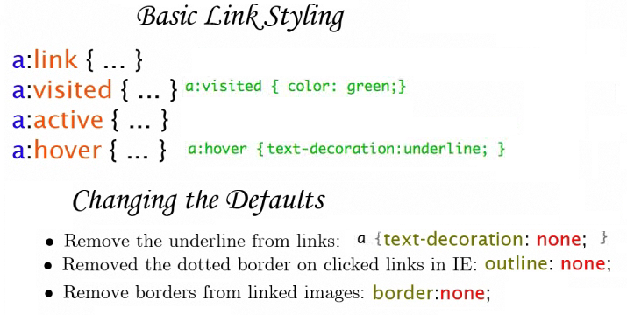

A:link Defines the style for normal unvisited links.  
A:visited Defines the style for visited links.  
A:active Defines the style for active links. A link becomes active once you click on it.  
  
A:hover Defines the style for hovered links. A link is hovered when the mouse moves over it.  
Note: Not supported by Netscape browsers prior to version 6.

* **none :** Produces no text decoration.
* **underline :** Each line of text is underlined.
* **overline :** Each line of text has a line above it.
* **line-through :**Each line of text has a line through the middle.
* **blink :** Text blinks (alternates between visible and invisible).

**Hover:** Al estar encima, o un mousemove se pone de color rojo

<style type="text/css">  
 A:link {text-decoration: none}  
 A:visited {text-decoration: none}  
 A:active {text-decoration: none}  
 A:hover {text-decoration: underline; color: red;}  
</style>

[LOOK HERE](http://www.echoecho.com/csslinks.htm)

**Overline:** Al estar encima, o un mousemove se pone rojo con una linea encima

<style type="text/css">  
 A:link {text-decoration: none}  
 A:visited {text-decoration: none}  
 A:active {text-decoration: none}  
 A:hover {text-decoration: underline overline; color: red;}  
</style>



<style type="text/css">  
 A:link {text-decoration: none}  
 A:visited {text-decoration: none}  
 A:active {text-decoration: none}  
  
</style>

<style type="text/css">  
 A:link {background: #FFCC00; text-decoration: none}  
 A:visited {background: #FFCC00; text-decoration: none}  
 A:active {background: #FFCC00; text-decoration: none}  
 A:hover {background: #FFCC00; font-size:24; font-weight:bold;

color: red; }  
</style>



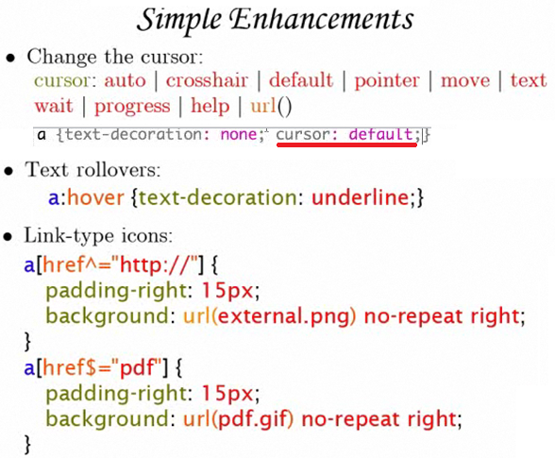

a[href^="**http://"]** ^ everything that starts with http://

a[href$="**pdf"**} $ everything that ends with pdf

**MAKING A REFLECTION**

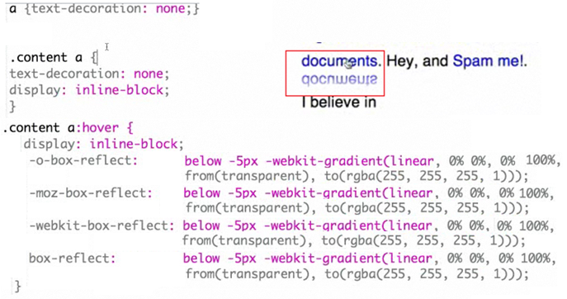

**ASSIGNING AN IMAGE**

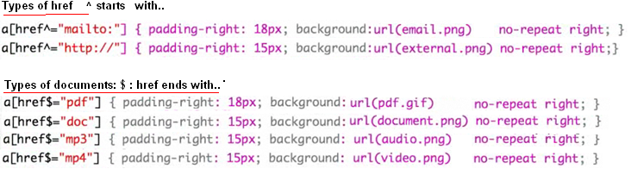

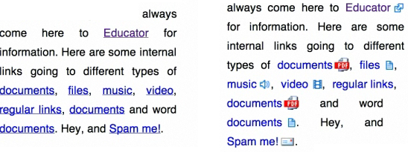

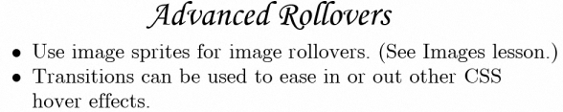

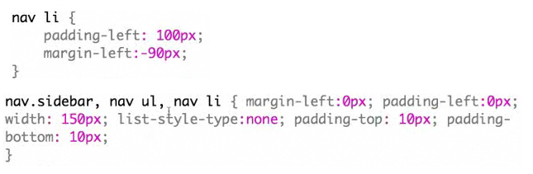

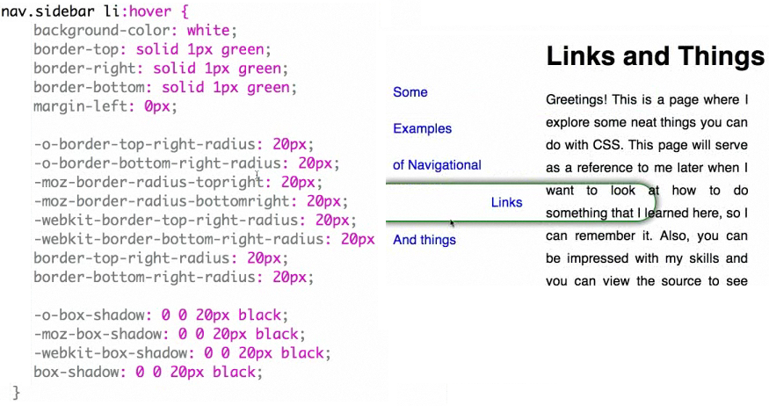

If you include the following code inside the hover, when hovering over the link it will create the effect in 4 seconds, like slow motion

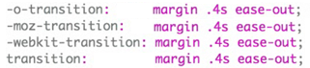

Transition: in the margin , 4 seconds, the way is : ease-out

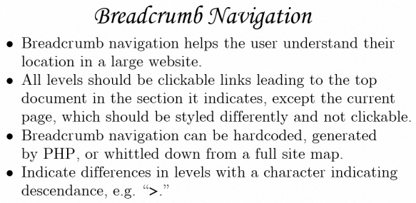

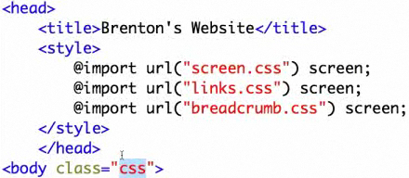

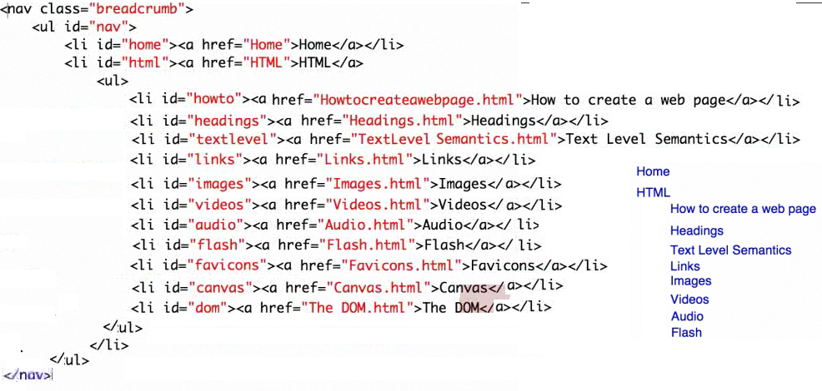

First hide

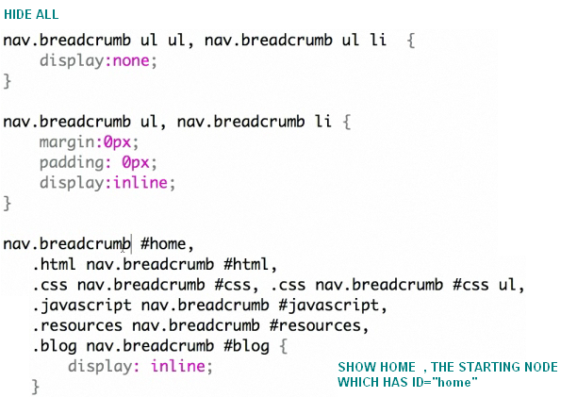

It will show 2 links

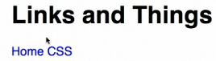

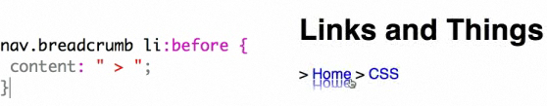

Apply “>” only to second one

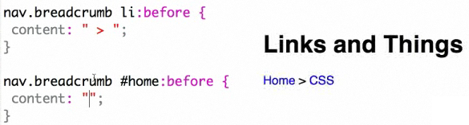

There is a div named links-page

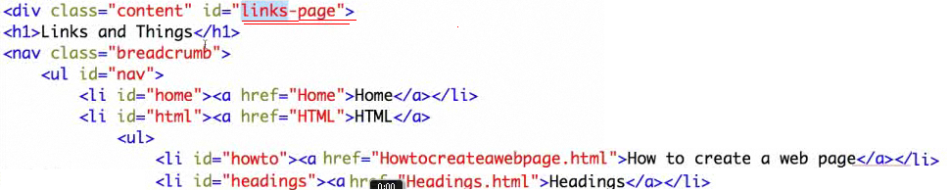

In links-page links

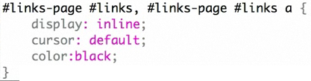

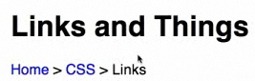

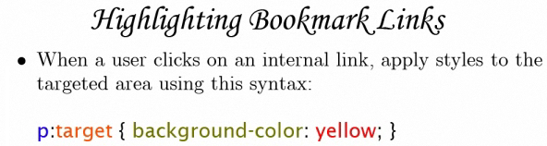

The link directs to #lastp

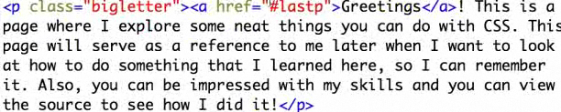

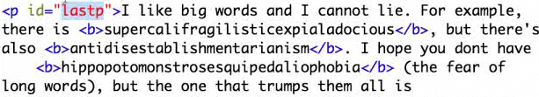

Al dar click en Greetings me direcciona al parrafo “lastp” pero si agrego el siguiente codigo me muestra el parrafo que escoja con un borde rojo



